Letter from Sherry: ASL
Dear Readers,
I’m pleased to present another exciting issue of our client newsletter, Vibrations! This issue features lots of great articles and stories – including everything from this year’s Kerry G. Wadman Award winner to a client-written poetry submission!
If you are interested in writing a story or article for the next edition of Vibrations, please talk to your intervenor, or send an email to social@deafblindservices.ca. The next newsletter will be produced in spring, and submissions are due by February 1, 2024.
In other news, DBCS is proud to be launching our new strategic plan, Reach Higher, Dream Bigger. Through extensive consultations with our community, we hoped to understand how we can better serve our community as we continue to grow and expand our reach.
I invite you to read the full plan by visiting our website. It is available in a wide selection of accessible formats, including ASL, DAISY, Accessible PDF, large print word document and a digital flipbook.
I hope you enjoy this edition of Vibrations as much as I did! Please read on to learn more about what’s happening here at DBCS and how you can get involved.

Sincerely,

Sherry Grabowski
Vice President
CNIB Deafblind Community Services

Introducing Margaret: Advisor, Client Relations, and Advocacy
ASL: Introducing Margaret
Hello, I'm Margaret, your new Advisor for Client Relations and Advocacy. I'm thrilled to have the opportunity to connect with you. My journey at DBCS spans over 11 rewarding years, and I have cherished every moment of it.
In the beginning, my role involved crafting curriculum for incoming intervenors back in 2012, a time that feels like a lifetime ago given the transformations since then. Since then, I have embraced the role of a Deaf Intervenor, a position I held closely to my heart due to the meaningful client interactions and the lasting relationships formed. While I miss that role, I'm equally excited to reconnect with clients in my new capacity.
Over the past several years, I've been dedicated to coordinating schedules for both intervenors and clients. Now, embarking on this fresh chapter, I am eager to dive into my new role. This opportunity enables me to engage with clients virtually, at their homes, or at a convenient location, providing a platform to discuss concerns, offer feedback, or simply exchange ideas. Additionally, I'm here to offer guidance and advocate on your behalf should any concerns arise, even if it requires traveling across Ontario to meet with you.
As part of my responsibilities, I will spread awareness about the services DBCS offers and act as a role model for new clients.
A bit about me: I am profoundly deaf and have an immense passion for dogs. In fact, I share my home in the countryside with several furry companions. I'm also an active member of a local dog rescue group that assists dogs from Texas. Each month, I take on the task of evaluating and preparing a dog for their forever home.
I am truly looking forward to meeting with all of you soon. Please feel free to reach out to me if you have any questions or require assistance.
Margaret Gosciminski
Email: margaret.gosciminski@deafblindservices.ca
Phone: (289) 260-3526

Deafblind Awareness Month 2023
ASL: Deafblind Awareness Month 2023
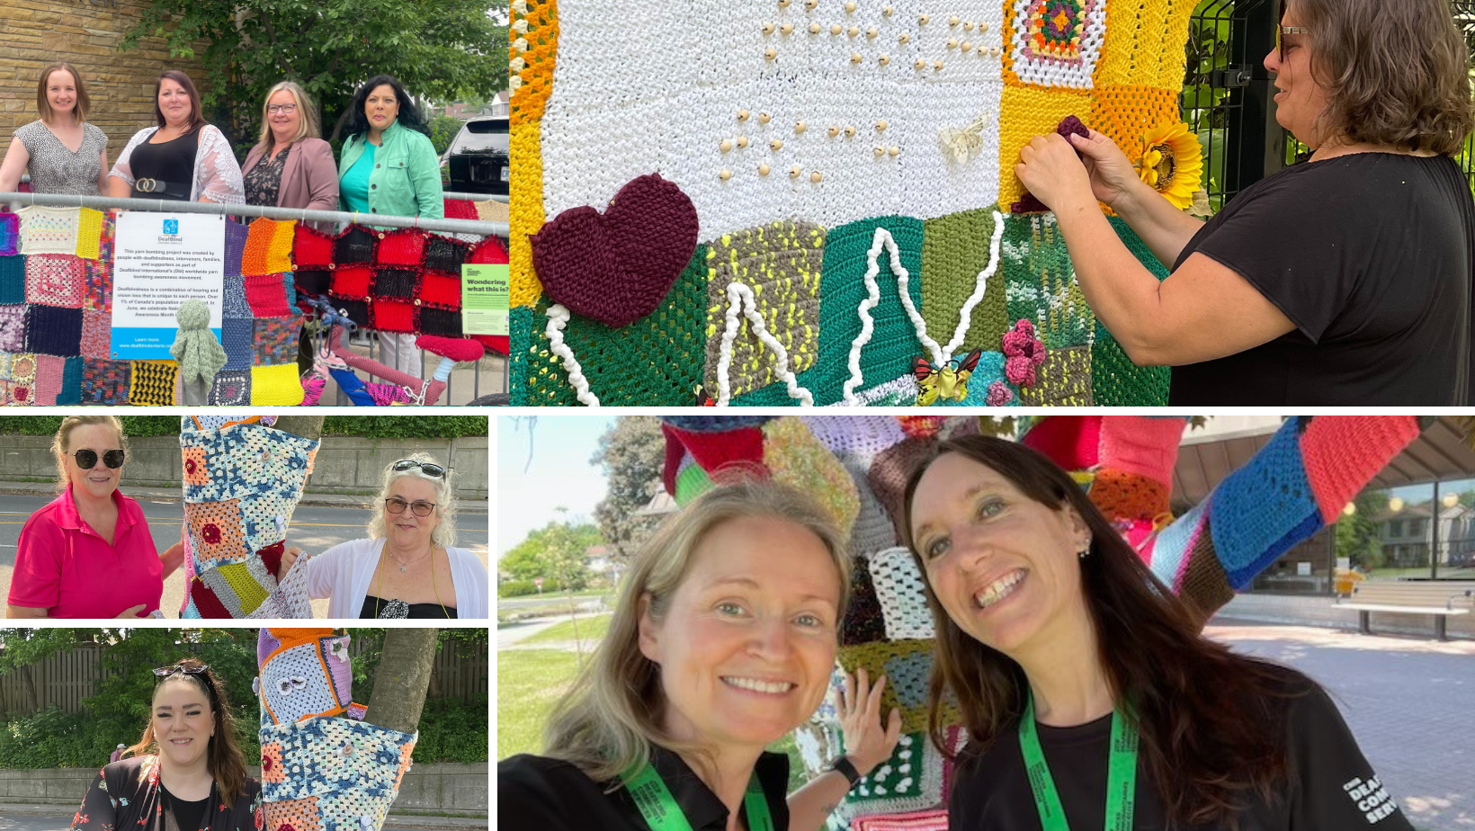
This year’s National Deafblind Awareness Month was an absolute success! A huge thank you goes out to everyone who participated this year. Whether you knitted or crocheted yarn squares, put together unique tactile art displays, or simply spread awareness about Deafblind Awareness Month – we can’t thank you enough.
This year, our teams participated in celebrations in more than 35 locations across the country. Our digital campaign helped us reach tens of thousands of people through our social media channels – ensuring we could continue to raise awareness and educate the public about the unique experiences and challenges that individuals who are Deafblind face every day.

Grant Summary: Communication in Service Provision for the Deafblind Community
ASL: Grant Summary

Introduction
More than 8% of Canadians over 15 years old live with a seeing, hearing disability or both. There are just over 466,000 Canadians with some degree of Deafblindness. This is going to increase as people age.
Current standards for making services accessible and inclusive are often overlooked. Service planners may consider accessibility only as an afterthought. This creates unintended barriers for people with disabilities. We believe it is better to design inclusive services from the start, using the best evidence and practices. Our project aims to understand:
- How adults with Deafblindness access services and their diverse needs.
- How to design, plan and evaluate services to meet these needs.

Project Goal
We will collaborate with the Deafblind community to create recommendations for making service planning and evaluation more inclusive, especially in areas regulated by the federal government.

What We Hope to Achieve
- Co-design guidelines for planning and evaluating services. These guidelines will prioritize making communication accessible and inclusive.
- Propose standards for diverse types of outreach for persons with Deafblindness.
- Identify best practices on inclusive decision-making and communication strategies.
- Develop, test, and assess training materials and resources to improve communication and service delivery.

Funder
Accessibility Standards Canada (ASC) Grant

Learn More
Reach out to research@cnib.ca

Electricity Support Program available for eligible Ontario electricity customers
ASL: Electricity Support Program
As the cost of living goes up, we are all looking for ways to save money. In Ontario, the Ontario Energy Board has an Electricity Support Program available to electricity account holders with lower incomes. This program provides a monthly credit to eligible customers. Visit the Ontario Electricity Support website to find out if you are eligible for this credit and information on how to apply.
British Columbia and Saskatchewan Energy Assistance Program
Eligible electricity customers in British Columbia and Saskatchewan may qualify for free energy saving products and advice. Visit the BC Hydro website or SaskPower website for more information about eligibility and products available.

Poetry Submission
ASL: Poetry Submission
Vibrations is proud to share our first ever client written poetry submission. The poet, Katharine Garrett, is a DBCS client, and shared her poem “Face Challenges” in an effort to express her experience as an individual who is Deafblind. We hope you enjoy Katherine’s submission, which is included below:

Face Challenges
We have so many challenges to face,
And we face so many challenges.
We may be in a slower pace,
It’s so hard to keep them in balance.
It’s never a race,
We always seem to manage.
With our ability to brace,
Sometimes we end up at a stance.
With our strength and confidence to face the challenges,
And learn from the challenges that we have faced.

By: Katharine Garrett

Deafblind Services in British Columbia: A History
ASL: Deafblind Services in B.C.
By Eddie Morten
Since the mid-1980s, the Deafblind community has been advocating for access to Deafblind services in province of British Columbia. In 2022, the province finally celebrated a long-awaited milestone – the establishment of intervenor services in British Columbia. After many years of effort and collaboration, we are thrilled to be welcoming CNIB Deafblind Community Services as an official service provider in Vancouver and parts of British Columbia.

Acknowledgments
We extend our gratitude to Sherry Grabowski from DBCS and Theresa Tancock from the Canadian Deafblind Association of BC for their efforts. Their work led to a meeting with the British Columbia government in June 2022, resulting in $750,000 in funding for a two-year project.

The Journey Begins (1980s-2000s)
This achievement's history dates back to the mid-1980s when discussions between Deafblind individuals and CNIB’s Deafblind Service staff laid the groundwork for the concept of an intervenor service. This service would provide daily assistance to Deafblind clients. A proposal letter in 1989 led to the establishment of the British Columbia Association of the Deafblind (BCADB) as an advocacy group.
In 1991, Eddy Morten, President of BCADB and a member of CNIB’s advisory board, joined forces with CNIB to help illustrate the need for funding to establish intervenor services in the province. Despite their efforts, they were unsuccessful – and it wasn’t until the mid-1990s that CNIB was able to establish a Volunteer Intervenor Program (VIP). Sadly, due to financial constraints, the program closed only a few years later in 2005.
In 2007, the Deafblind Society Service resurrected the VIP, appointing Eddy Morten to drive the program's progress.

Entering the 2010s
The effort to restore the VIP was successful and the Deafblind Society Service (DBSS) received $2M in funding, which sustained the program until 2012. After this funding was depleted, the VIP closed, followed by the closure of DBSS in 2014.
Before DBSS's closure, funding was provided to the Greater Vancouver Association of the Deaf (GVAD) to transition Deafblind Club members from DBSS to GVAD. This transition led to the creation of the Deafblind Planning Committee (DBPC).
Eddy Morten was appointed as the DBPC Chair and became a member of GVAD’s Board of Directors. A town hall meeting was held in May 2013 involving Deafblind members and their families, resulting in the identification of needs such as a weekly Deafblind Drop-in, organized outings, and the establishment of an intervenor service. Around the same time, DBPC received a generous donation of $25,000.00 from the Well-Being Program, inspired by an award received from a family member's estate. The funds were allocated to support the Deafblind Community.
In 2016, DBPC initiated discussions about potential agents and plans to develop a new intervenor service. However, due to communication challenges and financial difficulties within GVAD, these plans collapsed. Eventually, in either 2017 or 2018, DBPC decided to become independent from GVAD, reclaiming the funds held in its own account.

The Wavefront Centre's Efforts
Prior to the onset of the Covid-19 pandemic, the Wavefront Centre for Communication Accessibility (WCCA) received funding from the United Way to launch the Therapeutic Activation Program for Older Adults & Seniors (TAPS). Under the guidance of program coordinator Ryan Ollis, this initiative aimed to support Deafblind seniors through monthly workshops and an intervenor service. However, this intervenor service had limitations, with clients receiving a maximum of 3 hours of service twice a month.

A Turning Point in 2022
During National Deafblind Awareness Month in June 2022, Sherry and Theresa made a significant visit to Victoria, unveiling surprising funding support to establish an intervenor service through CNIB. This development was spurred by the new Access British Columbia Act (ABCA).

Celebrating Collaboration at the Deafblind International Conference
ASL: Deafblind International Conference
In the heart of July, the CNIB Deafblind Community Services (DBCS) team embarked on an enriching journey to the 18th International World Conference hosted by Deafblind International. This week-long event, held at the Shaw Centre in Ottawa, welcomed more than 600 participants, including individuals who are Deafblind, researchers, interpreters, intervenors, support professionals, community organizations, and stakeholders from across the world.
The conference proved to be a resounding success, and was a great opportunity to have important conversations and to discuss research within the field of Deafblindness. Attendees has the opportunity to listen to engaging guest speakers, and hear from researchers from all across the world.
Attendees also had the chance to visit booths during breaks between sessions. Both CNIB and DBCS hosted booths, with CNIB at the SmartLife table, demonstrating the latest accessible products, and DBCS at the Certification Booth.
However, the conference's most significant message centered around the importance of collaboration. It served as a genuine opportunity for individuals to come together as a global community. Together, we reflected on our progress, while also imagining a brighter future for all people who are Deafblind.
“Even though we are fairly far advanced, there are people who are even more advanced than Canada. So, you get to really appreciate where you are…it’s motivation on both sides – to know your past…but know that your future can be even brighter,” said Penny Bennett, Chair of the DBCS Board of Directors.
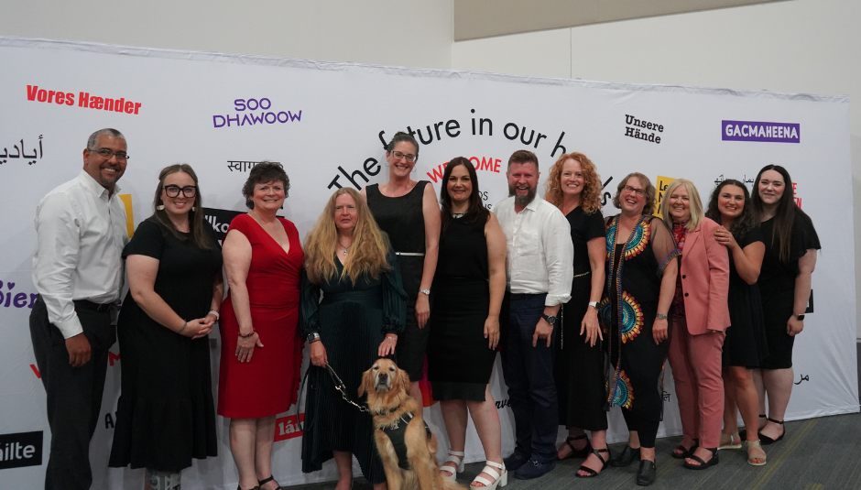

Champions of Inclusive Education: Celebrating Nina, Krissy, and Jaime!
ASL: Champions of Inclusive Education
By Carolina Cohoon
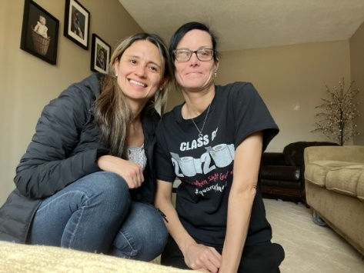
Meet Nina, Krissy, and Jaime – three remarkable individuals making waves in our quest for a more inclusive learning environment.
Nina, a pivotal member of our team, plays a crucial role in content review through screen readers and magnification tools. Her expertise provides us with invaluable insights into the accessibility of tools, resources, and software for the communities we serve.
Krissy, with her extraordinary contribution, is bridging communication gaps by translating quizzes into American Sign Language (ASL). At DBCS, we prioritize individual communication preferences, ensuring everyone can both receive and convey information comfortably.
Jaime emerges as the mastermind behind the innovative Food for Eye Health module series. Collaborating with a Registered Dietitian, Krissy, and Nina, this dynamic team is crafting an entirely new set of lessons using a universal design for learning approach. This ensures that these lessons will be accessible in various formats, including EPUB, learning management systems, and accessible PDFs.
Thanks to the generous support of the LLSC, we had the privilege of recognizing the invaluable contributions of Nina, Krissy, and Jaime to Literacy and the creation of Equitable Learning Environments.

